Case Studies of Homes
My Team Sold that Other
Agents Couldn’t Sell
Each of the case studies below is a house that another agent failed to sell… that I listed… and successfully sold.
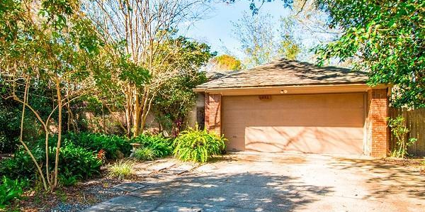
Case Study #1: Home was for sale for about a year with two different Realtors. The seller hired me, and I sold it in a few weeks for the previous agent’s price.
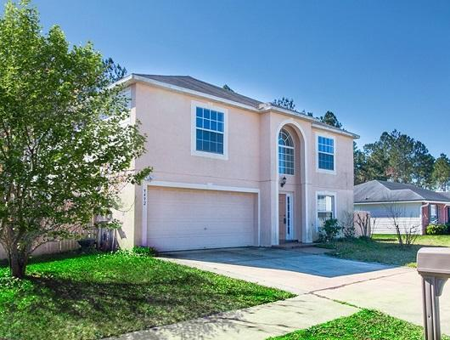
Case Study #2: Home was for sale for a year with 2 Realtors… and didn’t sell. I put the home on the market a month after the listing expired with the last agent. The seller left the same asking price. It sold in 2 weeks for 97% of the asking price.
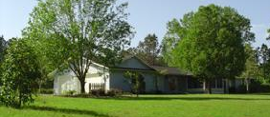
Case Study #3: Home was for sale for 6 months with another Realtor. The seller hired me, and I sold it in 16 days for 97% of the asking price.
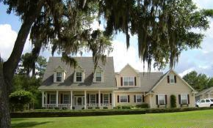
Case Study #4: Home was for sale for 6 months with another Realtor. The seller hired me, and I sold it in 72 days for 99.6% of the asking price.
Case Study #5: Home was for sale for 6 months with another Realtor. The seller hired me, and I sold it in 22 days for 98.5% of the asking price.
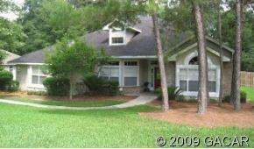
Case Study #6: Home was for sale for 6 months with another Realtor. The seller hired me, and I sold it in 4 months for 97% of the asking price.
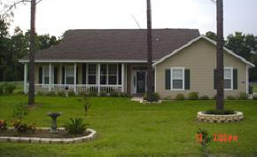
Case Study #7: Home was for sale for 6 months with another Realtor. They hired me, and I sold it in 98 days for 100% of the asking price.
Case Study #8: Home was for sale for 6 months with another Realtor. The seller hired me, and I sold it in 81 days for 99.5% of the asking price.
Case Study #9: Home was for sale for 6 months with another Realtor. They hired me, and I sold it in 20 days for $10,000 above the asking price.
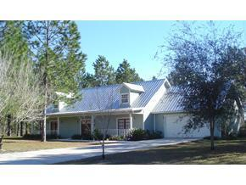
Case Study #10: Home was for sale for 12 months with two other Realtors. The sellers hired me, and I sold it in 8 days for 98.3% of the asking price.
This was an interesting sale. The sellers had been trying to sell the home for a year and really struggled at it. The reason the home wasn't selling was not because of the price.
(The home was absolutely worth what the sellers were asking for.) BUT, there was a minor complication. The neighborhood where the home was located was considering some major upgrades.
They were considering assessing everyone in the neighborhood for $7,000 to $8,000 each to cover the cost. The buyers would look at the house and get cold feet because of the pending assessment.
Most of the buyers would say something like, "I'll buy your house, but I want an $8,000 discount on the price because of the special assessment.”
The sellers would reply, "I'm glad to sell you my house, but I am not going to discount $8,000 because we think the special assessment is not going to go through."
The sellers told me about the problem when I put the home up for sale. I thought about it for a few minutes and proposed a solution.
Here’s what I told them:
"Let's sell the house and agree to hold $8,000 in escrow. If the special assessment goes through within a year, the buyers get that $8,000. If it does not go through within a year, the $8,000 goes to you."
We all agreed that that sounded like a good idea. The home sold very fast for 98.3% of the asking price. $8,000 was put into escrow, and an attorney typed up the escrow agreement.
It turned out that the sellers were correct. The opposition in the neighborhood was strong and the special assessment never went through.
A year later, the sellers received the $8,000 that had been put into escrow. This story gives you a great example of some of the problems a good agent solves on a day-to-day basis.
I don’t think my idea was particularly revolutionary, but it did solve the problem. Honestly, I am sometimes surprised at how little effort other people put into selling a home.
Case Study #11: Home was for sale for 5 months with another Realtor. The seller hired me, and I sold it in 71 days for 99.6% of the asking price.
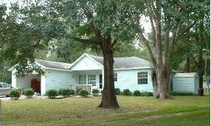
Case Study #12: Home was for sale for 11 months with another Realtor. The seller hired me, and I sold it in 4 months for 97.5% of the asking price.
Case Study #13: Mike & Melinda Monaghan's Home was for sale for over a year with another Realtor. They hired me, and I sold it in 28 days for 100% of the asking price.
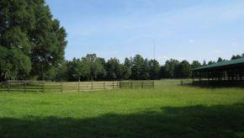
Case Study #14: Home was for sale for 8 months with another Realtor. The sellers hired me, and I sold it in 46 days for 104% of the asking price. Multiple buyers fell in love with the home, and we had a bidding war.
Case Study #15: Home was for sale for 6 months with another Realtor. The sellers hired me, and I sold it in 4 months for 97.8% of the asking price.
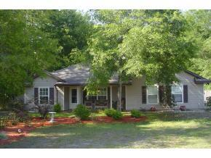
Case Study #16: Home was for sale for 7 months with another Realtor. The sellers hired me, and I sold it in 81 days for 96.8% of the asking price.
Case Study #17: Home was for sale for 7 months with another Realtor. The seller hired me, and I sold it in 6 months for 96.4% of the asking price.
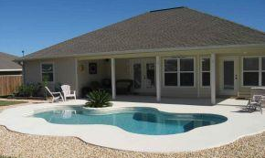
Case Study #18: Home was for sale for 7 months with another Realtor. The seller hired me, and I sold it in 6 months for 96.4% of the asking price.
Case Study #19: Home was for sale for 6 months with another Realtor. The seller hired me, and I sold it in 4 months for 96% of the asking price.
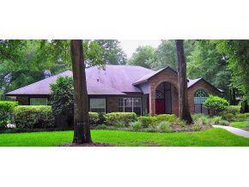
Case Study #20: Home was for sale for 6 months with another Realtor. They hired me, and I sold it in 94 days for 100% of the asking price.

Eric Pugh

Want To Sell Your Home For More Money?
If You Said "Yes," Give Me A Call
Right Away At (904) 746-0082.
The Home they sold

Jessie Pugh

