You can find free, public domain images to post in place of the images below on https://www.pexels.com or by searching “public domain images” on any search engine.

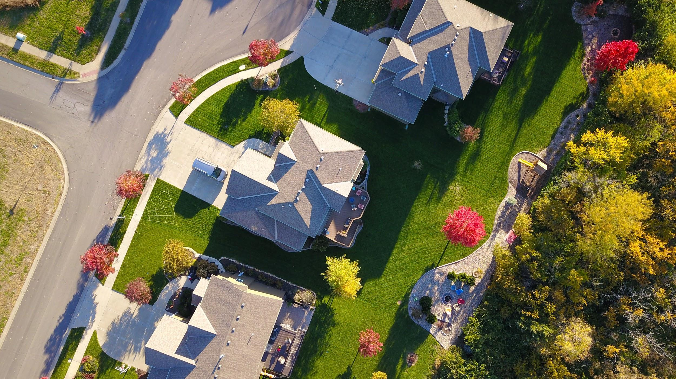
Text variation 1: I’m currently offering free professional real estate photos to local For Sale by Owner home sellers. This is a 100% free service with no obligation to list with me. I’m simply offering a “free sample,” so to speak, of what I can do for them. Do you know anyone who might be interested?

Text variation 2: Do you know anyone thinking about selling their home For Sale by Owner who would be interested in getting free professional real estate photos taken of their home? I’m currently offering this promo as a “free sample” of what I can do — with absolutely no obligation to list with me. If you know anyone who might be interested, please let me know!

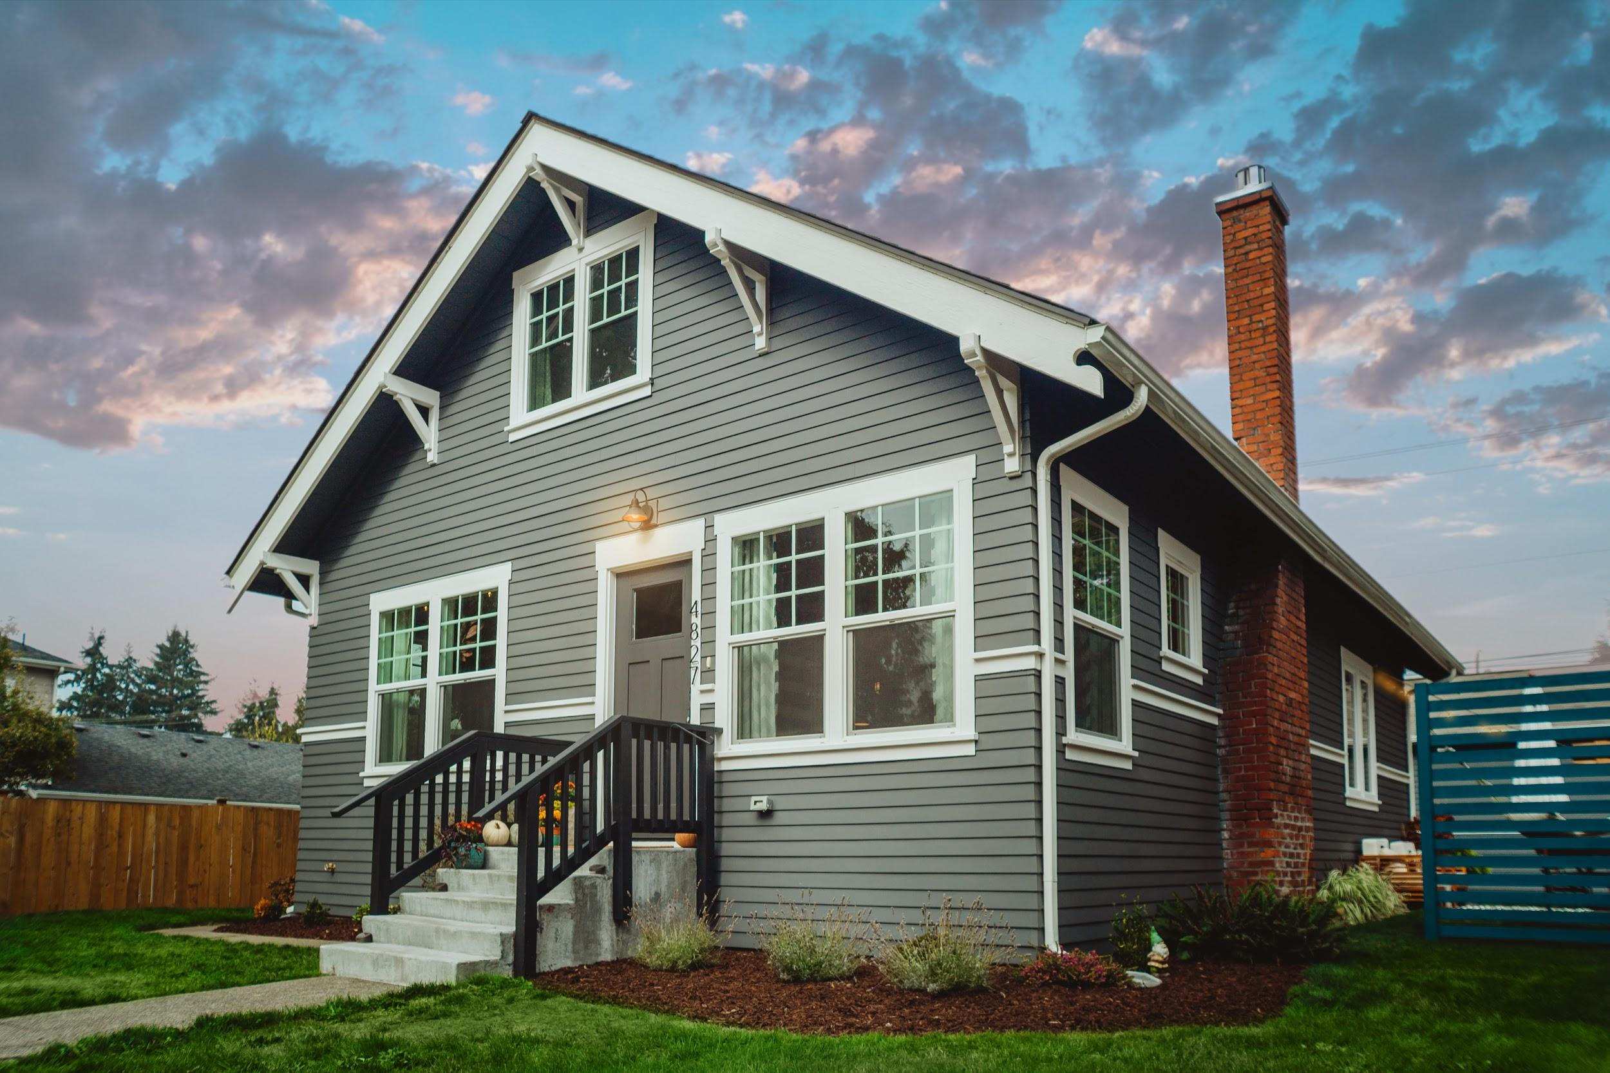
Text variation 3: Do you know anyone thinking about selling their home For Sale by Owner who would be interested in getting free professional real estate photos taken of their home? Message me to find out more!

