You can find free, public domain images to post in place of the images below on https://www.pexels.com or by searching “public domain images” on any search engine.

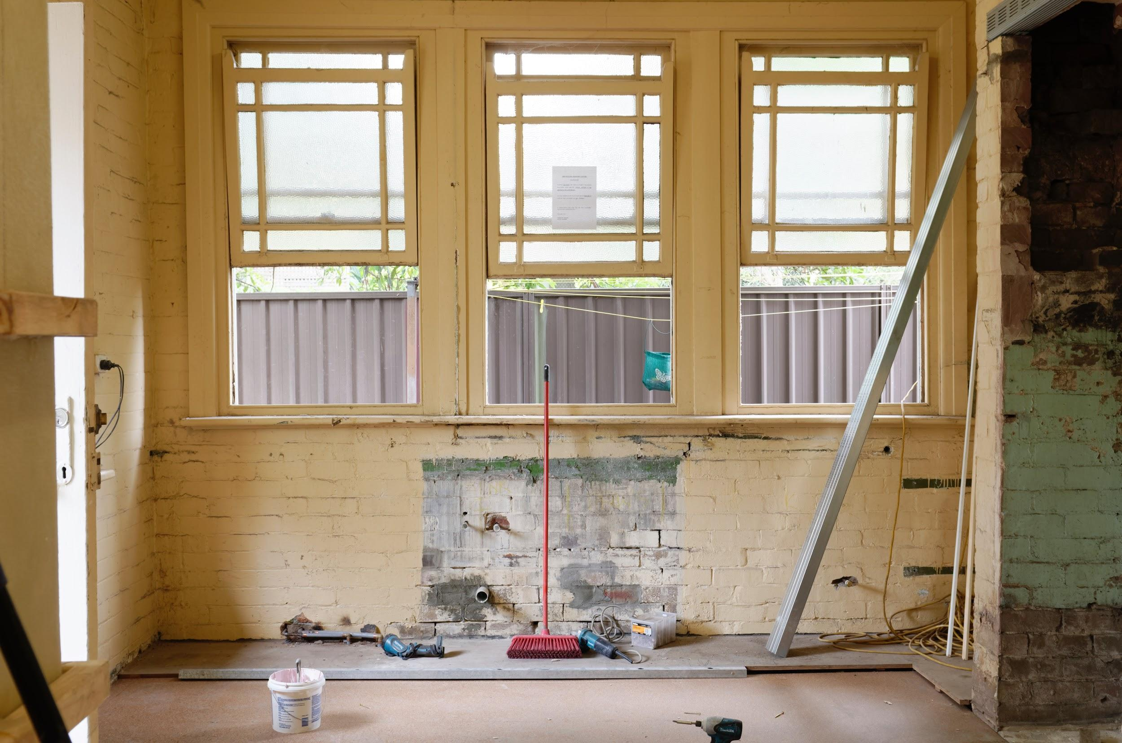
Text variation 1: Ever wondered what changes you can make to your home that would pay off big time if and when you wanted to sell? If so, contact me to find out which improvements can offer you the greatest return on investment. This advice comes with no obligation to list with me now or in the future. Do you know anyone who might be interested?

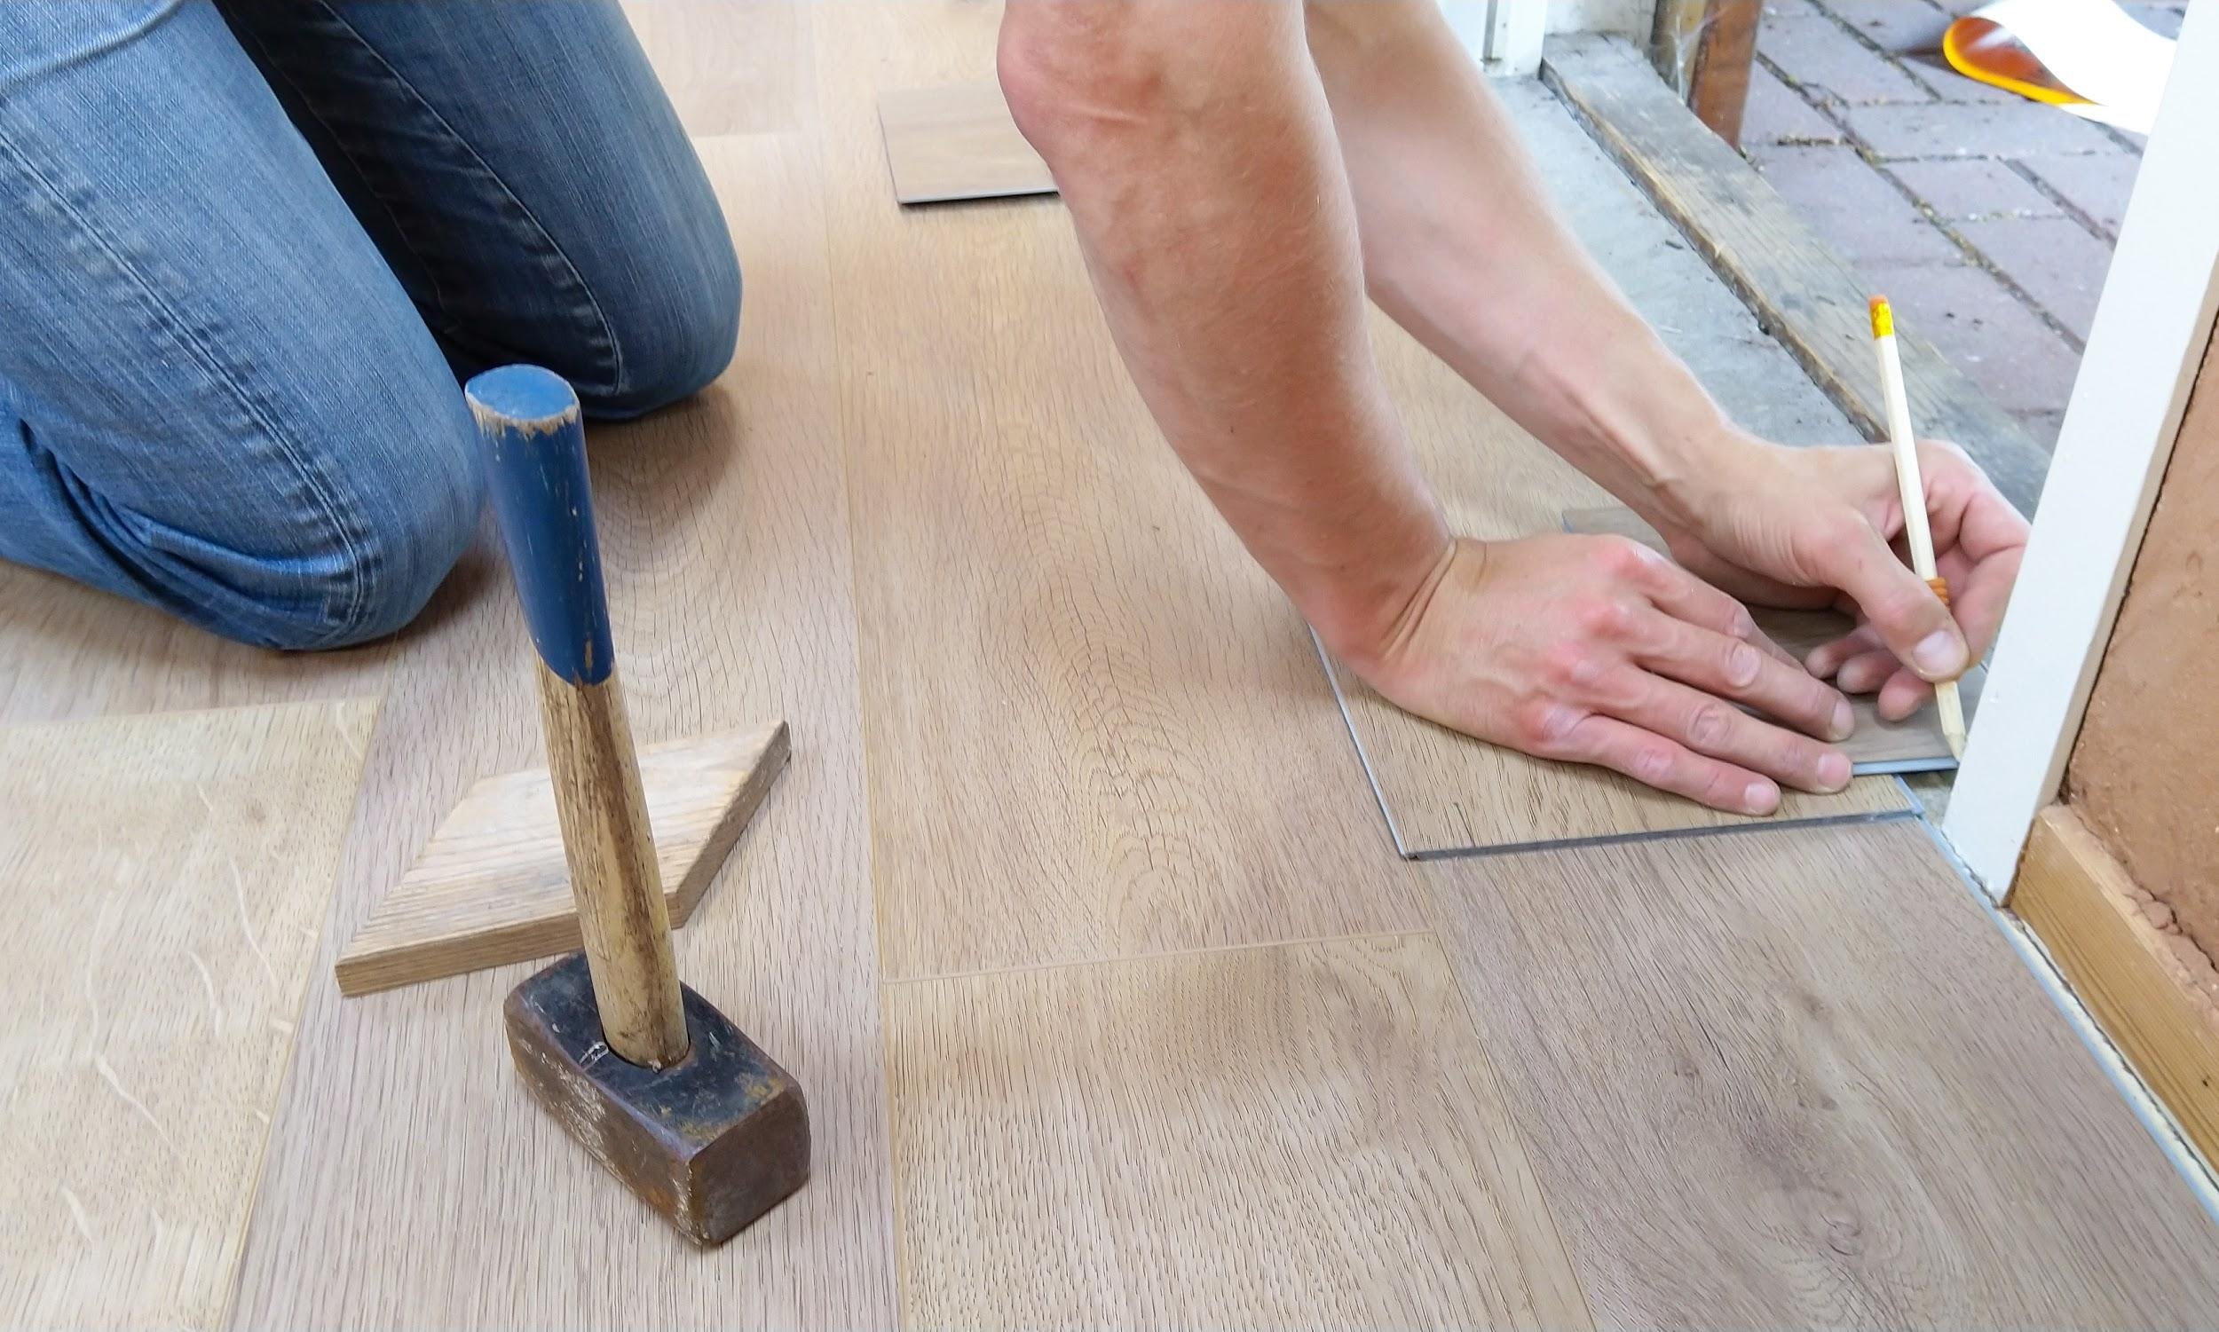
Text variation 2: Do you know anyone thinking about remodeling who would benefit from free advice on which improvements offer the greatest return on investment? This advice comes with no obligation to list with me now or in the future. Please let me know!

Text variation 3: Do you know anyone thinking about remodeling who would benefit from free advice on which improvements offer the greatest return on investment? Message me for details!

