You can find free, public domain images to post in place of the images below on https://www.pexels.com or by searching “public domain images” on any search engine.

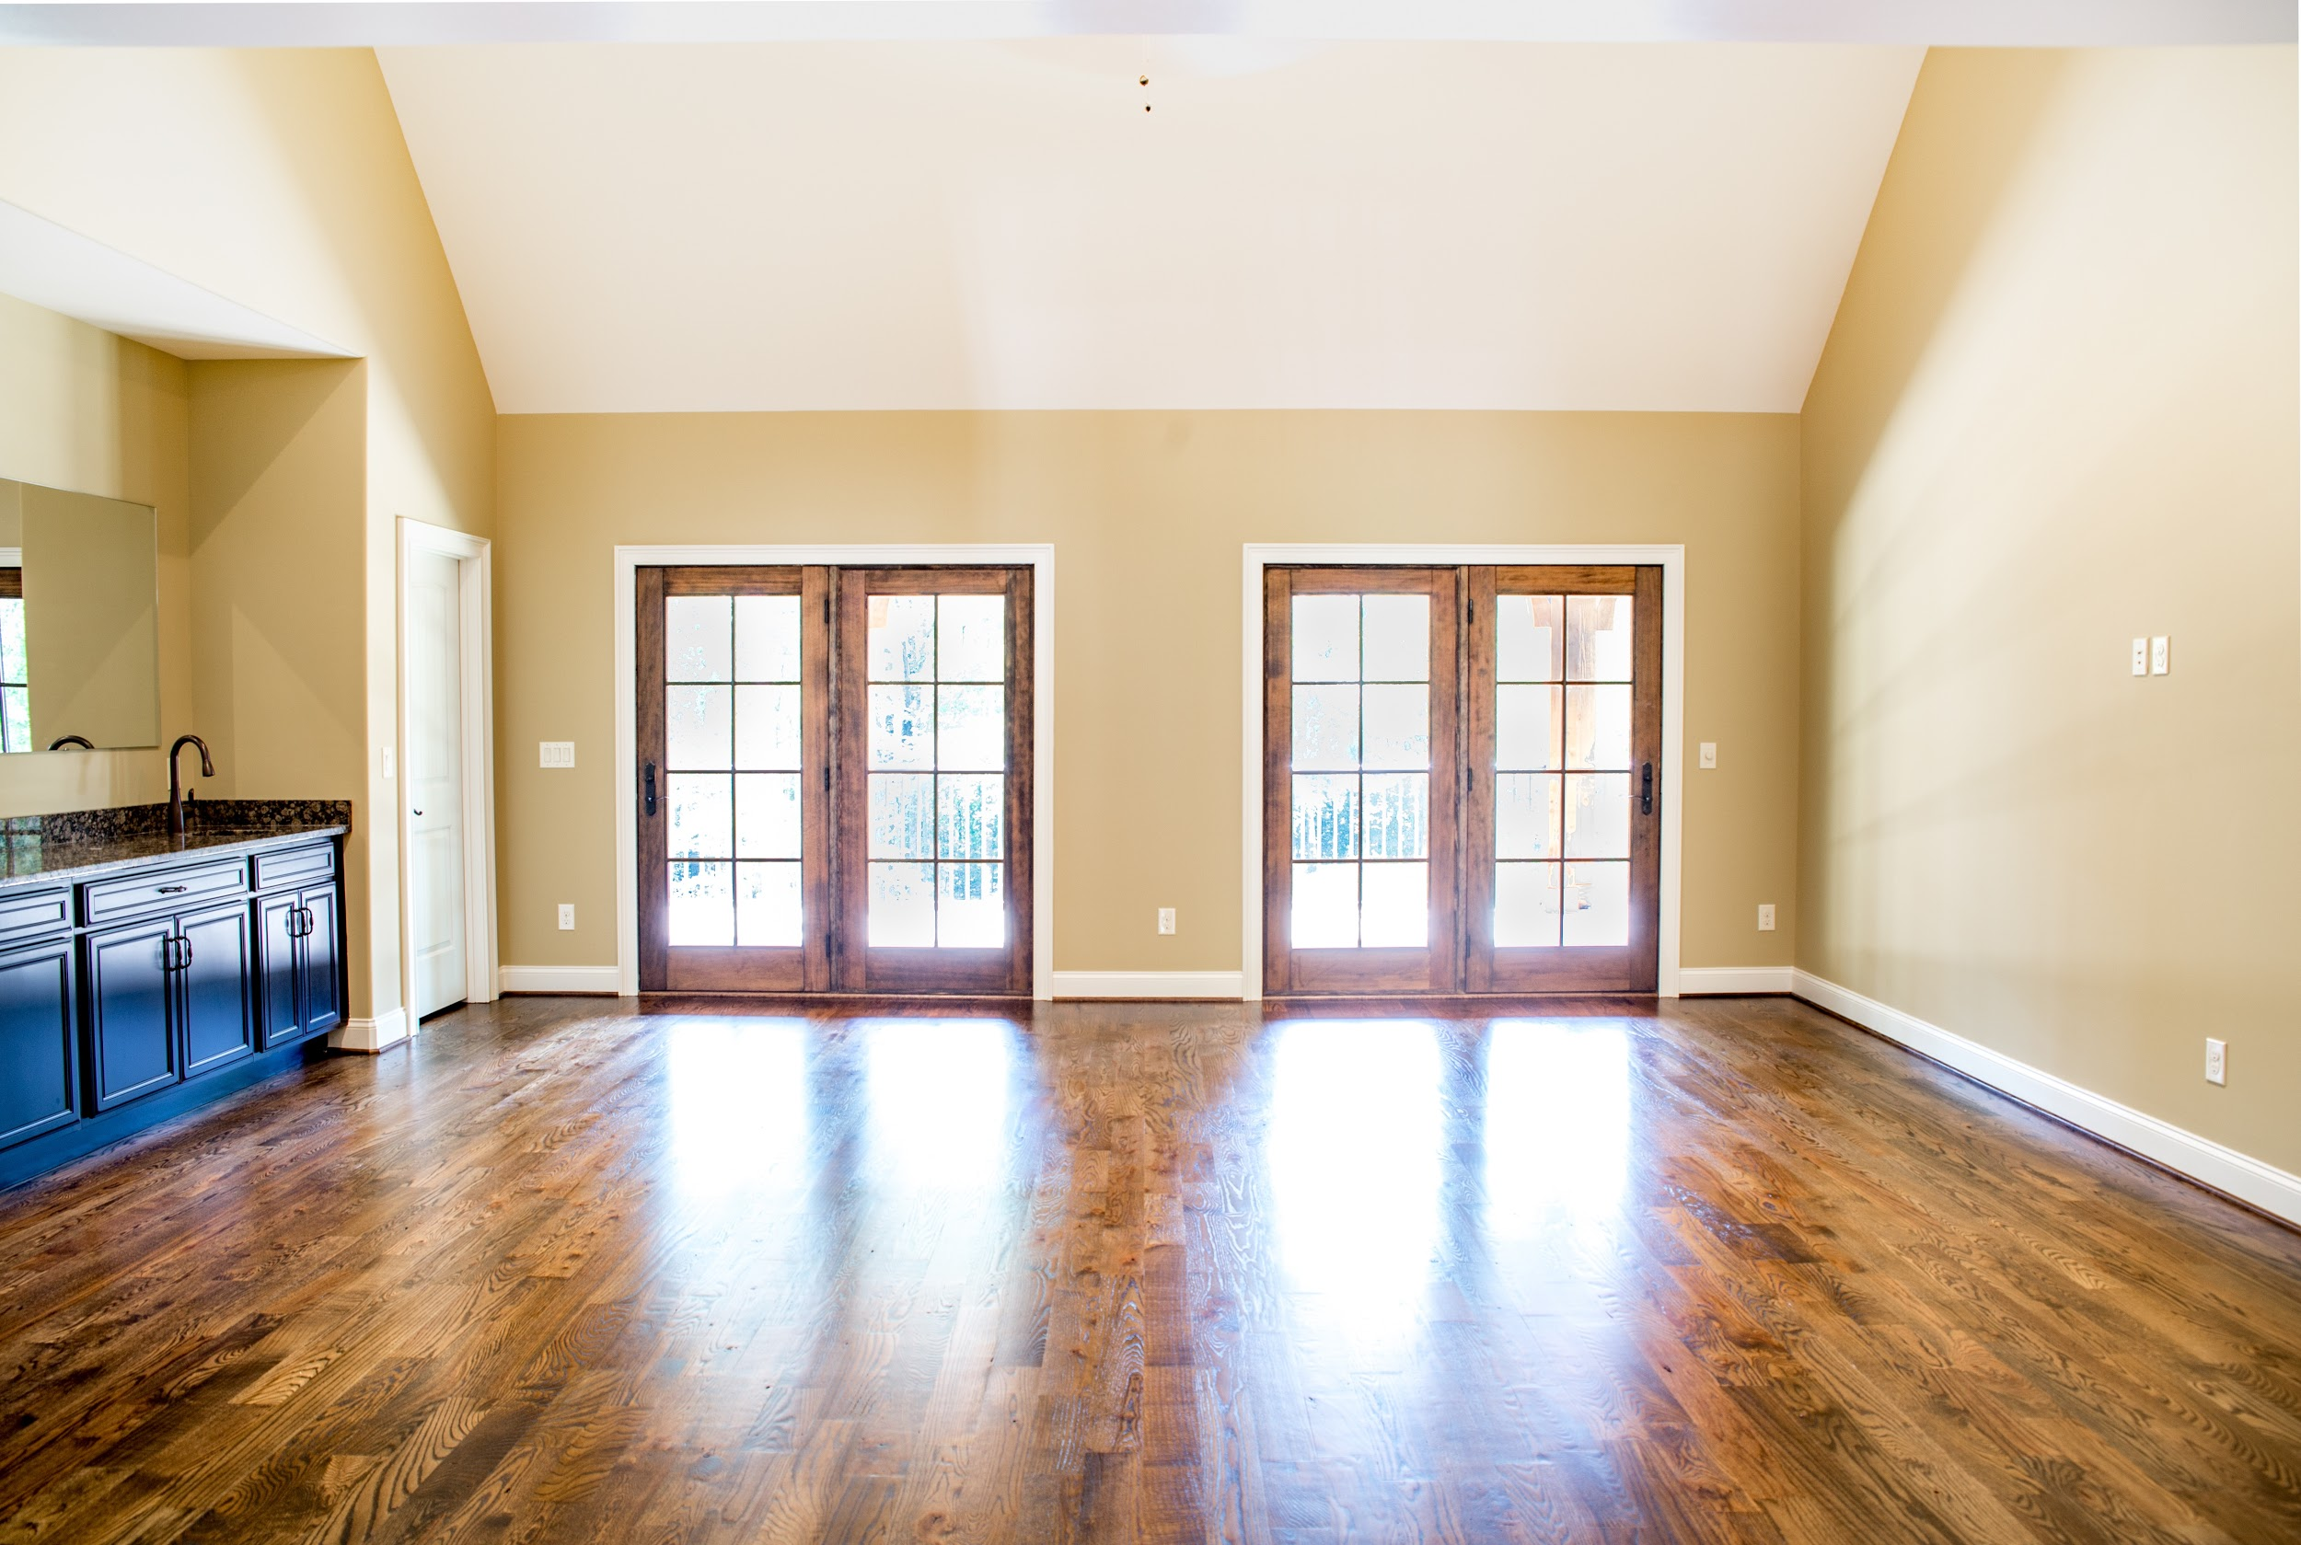
Text variation 1: Do you know anyone with a home sitting empty who would benefit from hearing free advice on how to sell it? Message me for details!

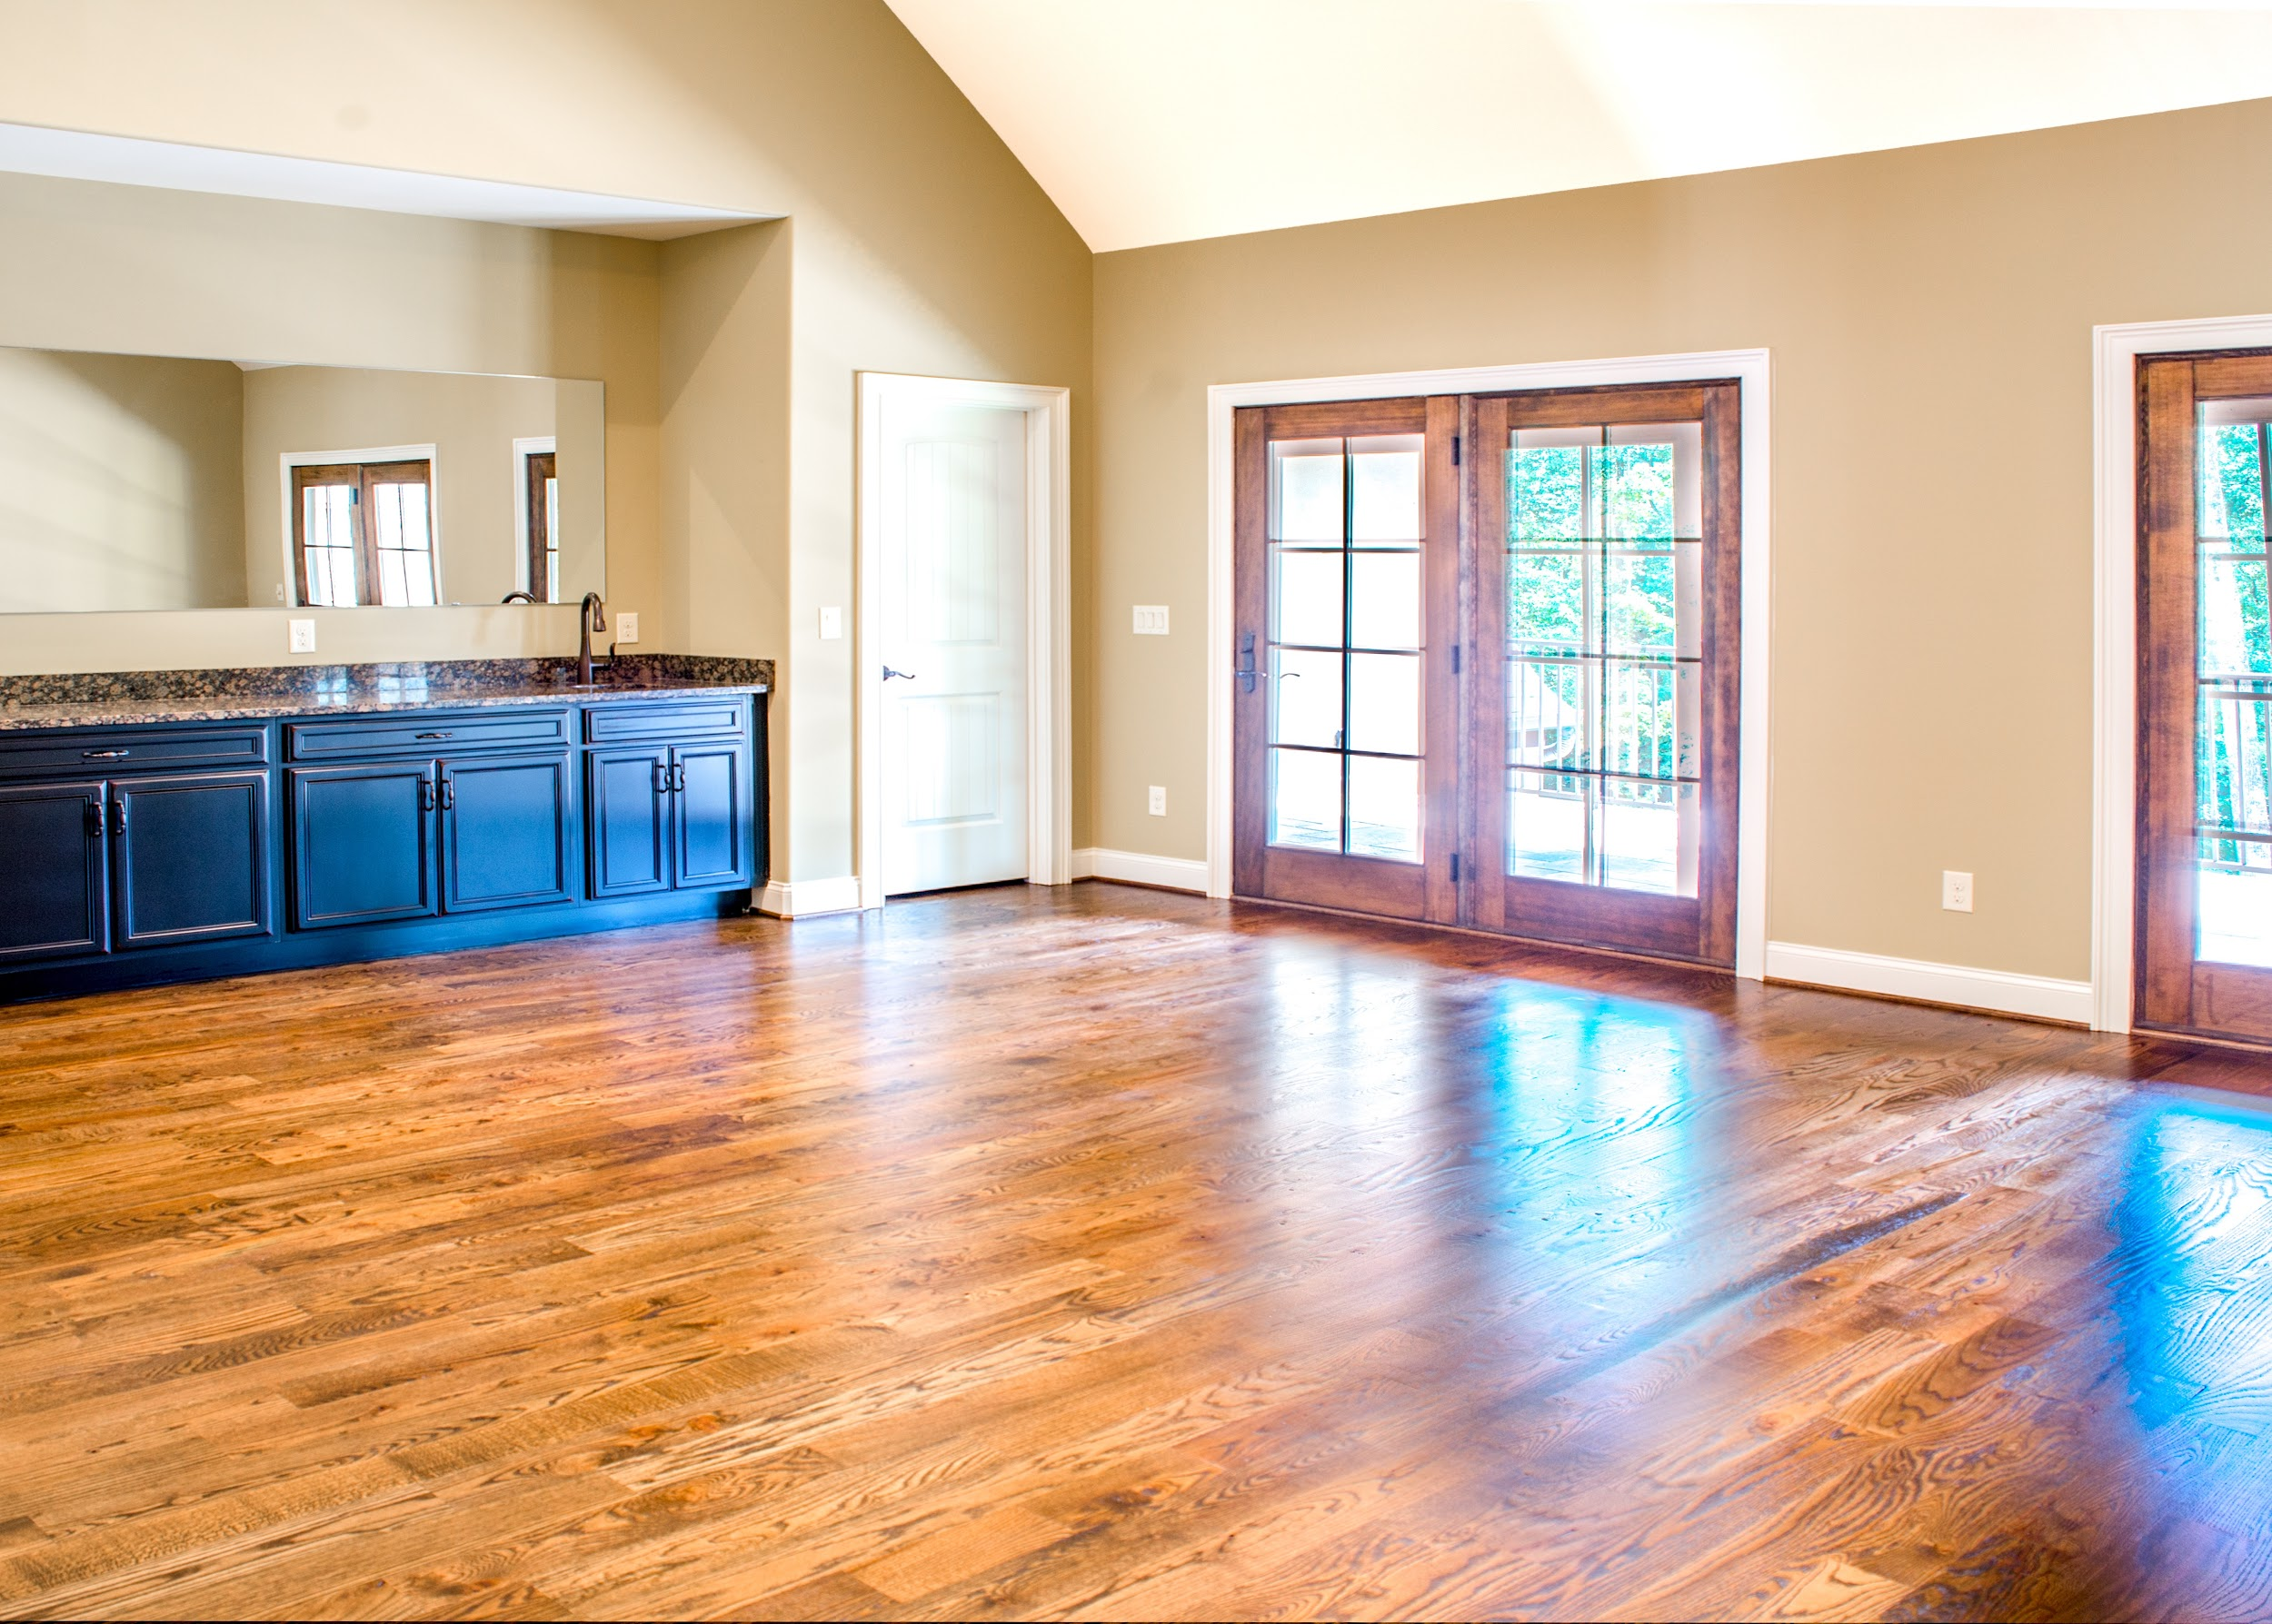
Text variation 2: Did you know that vacant homes are typically easier to sell than owner-occupied homes? If your home has been sitting empty, “collecting dust,” it’s time you got it off your hands! Message me to find out how!

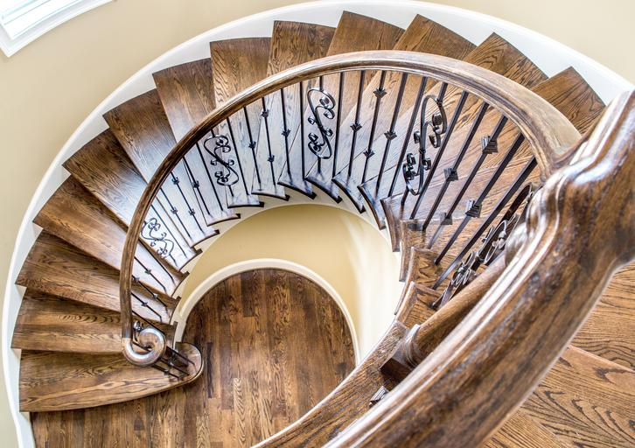
Text variation 3: Do you know anyone with a vacant home who would benefit from hearing free advice on how to sell it? I’ll show them why vacant homes are typically easier to sell than owner-occupied homes and how they can get top dollar if they do decide to sell!

